**Requirement Gathering and Analysis Phase**

**Data Flow Diagram & User Stories**

|  |  |
| --- | --- |
| Date | 4 July 2024 |
| Team ID | SWTID1719938064 |
| Project Name | ShopEZ: E-Commerce Application |
| Maximum Marks | 3 Marks |

**Data Flow Diagrams:**

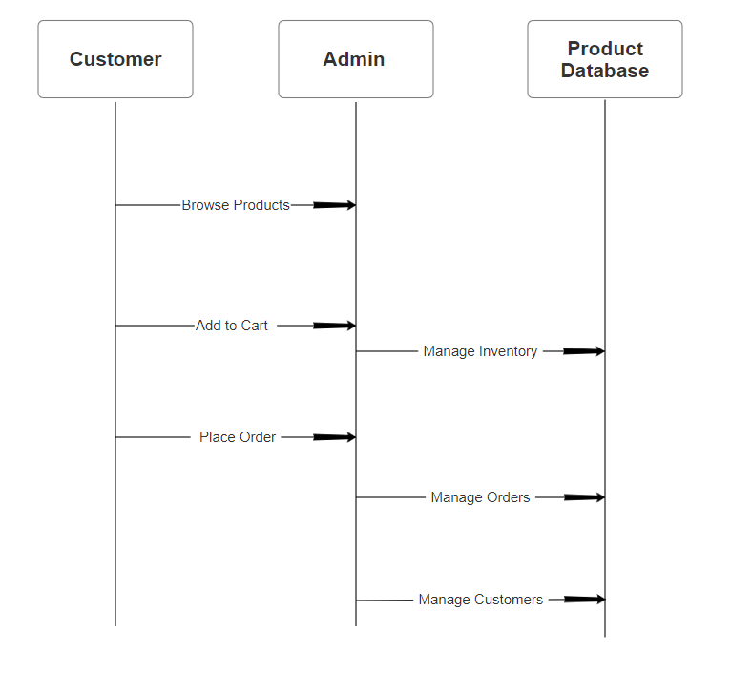

**User Stories**

Use the below template to list all the user stories for the product.

| **User Type** | **Functional Requirement (Epic)** | **User Story Number** | **User Story / Task** | **Acceptance criteria** | **Priority** | **Release** |
| --- | --- | --- | --- | --- | --- | --- |
| Customer (Mobile user) | Registration | USN-1 | As a user, I can login for the application by entering my phone number, password. | I can access my account if password is correct | High | Sprint-1 |
|  |  | USN-2 | As a user, I will receive confirmation OTP once I have registered for the application | I can receive confirmation email & click confirm | High | Sprint-1 |
|  |  | USN-4 | As a user, I can register for the application through Gmail | I can register & access the dashboard with Gmail Login. | Medium | Sprint-1 |
| Customer (Web user) | Login | USN-5 | As a user, I can log into the application by entering email/number & password | I can access my account/dashboard. | High | Sprint-1 |
| Customer (Web user) | Dashboard | USN-6 | As a user, I can view and manage my orders from the dashboard of account. | I can see my order history and manage ongoing orders. | High | Sprint-2 |
| Customer Care Executive | Support | USN-7 | As a customer care executive, I can view and respond to customer queries. | any customer who is registered. | High | Sprint-1 |
| Administrator | User Management | USN-8 | As an admin, I can manage user accounts and authentications. | I can create, update, and delete user accounts. | High | Sprint-1 |
| Administrator | Analytics | USN-9 | As an admin, I can view and analyse what user is doing in application. | I can access user activity data and generate performance reports. | Medium | Sprint-2 |